**DAILY ONLINE ACTIVITIES SUMMARY**

|  |  |  |  |  |  |  |  |  |
| --- | --- | --- | --- | --- | --- | --- | --- | --- |
| **Date:** | **04-06-2020** | | | | | **Name:** | **Nihal Rafiq** | |
| **Sem & Sec** | **4th A** | | | | | **USN:** | **4AL18CS052** | |
| **Online Test Summary** | | | | | | | | |
| **Subject** | | **Microcontroller and Embedded System** | | | | | | |
| **Max. Marks** | | **30** | | **Score** | | | **16** | |
| **Certification Course Summary** | | | | | | | | |
| **Course** | **1. Python for Machine learning** | | | | | | | |
| **Certificate Provider** | | | **Great Learning Academy** | | **Duration** | | | **5 hours** |
| **Coding Challenges** | | | | | | | | |
| **Problem Statement:**  **1. Write a java program to read three integer values from the keyboard and find the sum of the values. Declare a variable “sum” of type int and store the result in it**  **2. Write a C++ program to find the missing number in array** | | | | | | | | |
| **Status: Executed** | | | | | | | | |
| **Uploaded the report in Github** | | | | | **Yes** | | | |
| **If yes Repository name** | | | | | **https://github.com/nihal-art/lockdown-coding** | | | |
| **Uploaded the report in slack** | | | | | **Yes** | | | |

Online Test Details:

The today’s online test was of MES. Score I received is 16/30

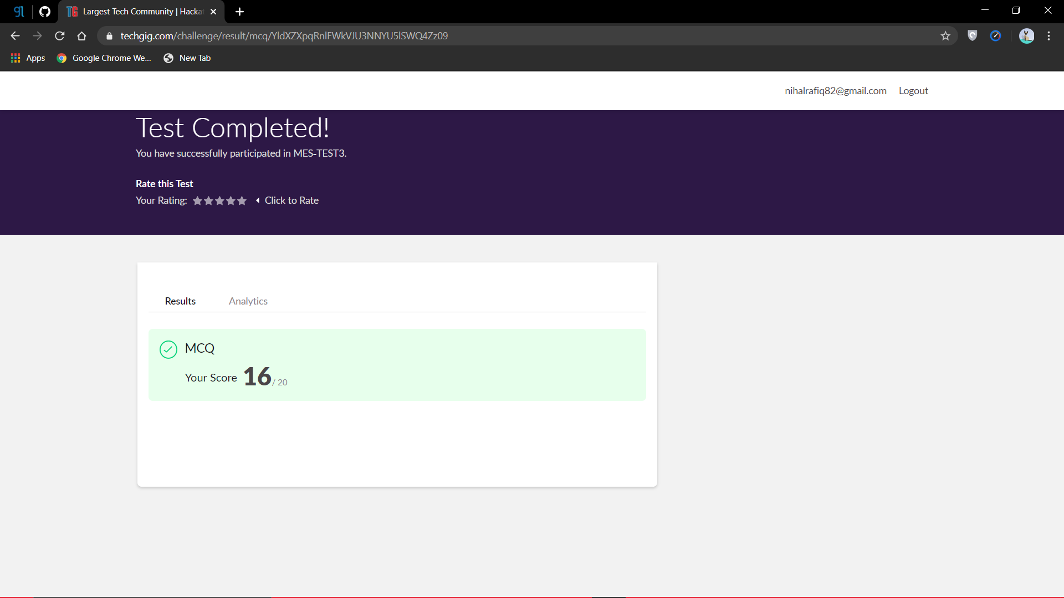

Certification Course Details:

Python for Machine Learning:

Python offers concise and readable code. While complex algorithms and versatile workflows stand behind machine learning and AI, Python’s simplicity allows developers to write reliable systems. Developers get to put all their effort into solving an ML problem instead of focusing on the technical nuances of the languages.



Coding Challenges Details:

1. Write a java program to read three integer values from the keyboard and find the sum of the values. Declare a variable “sum” of type int and store the result in it

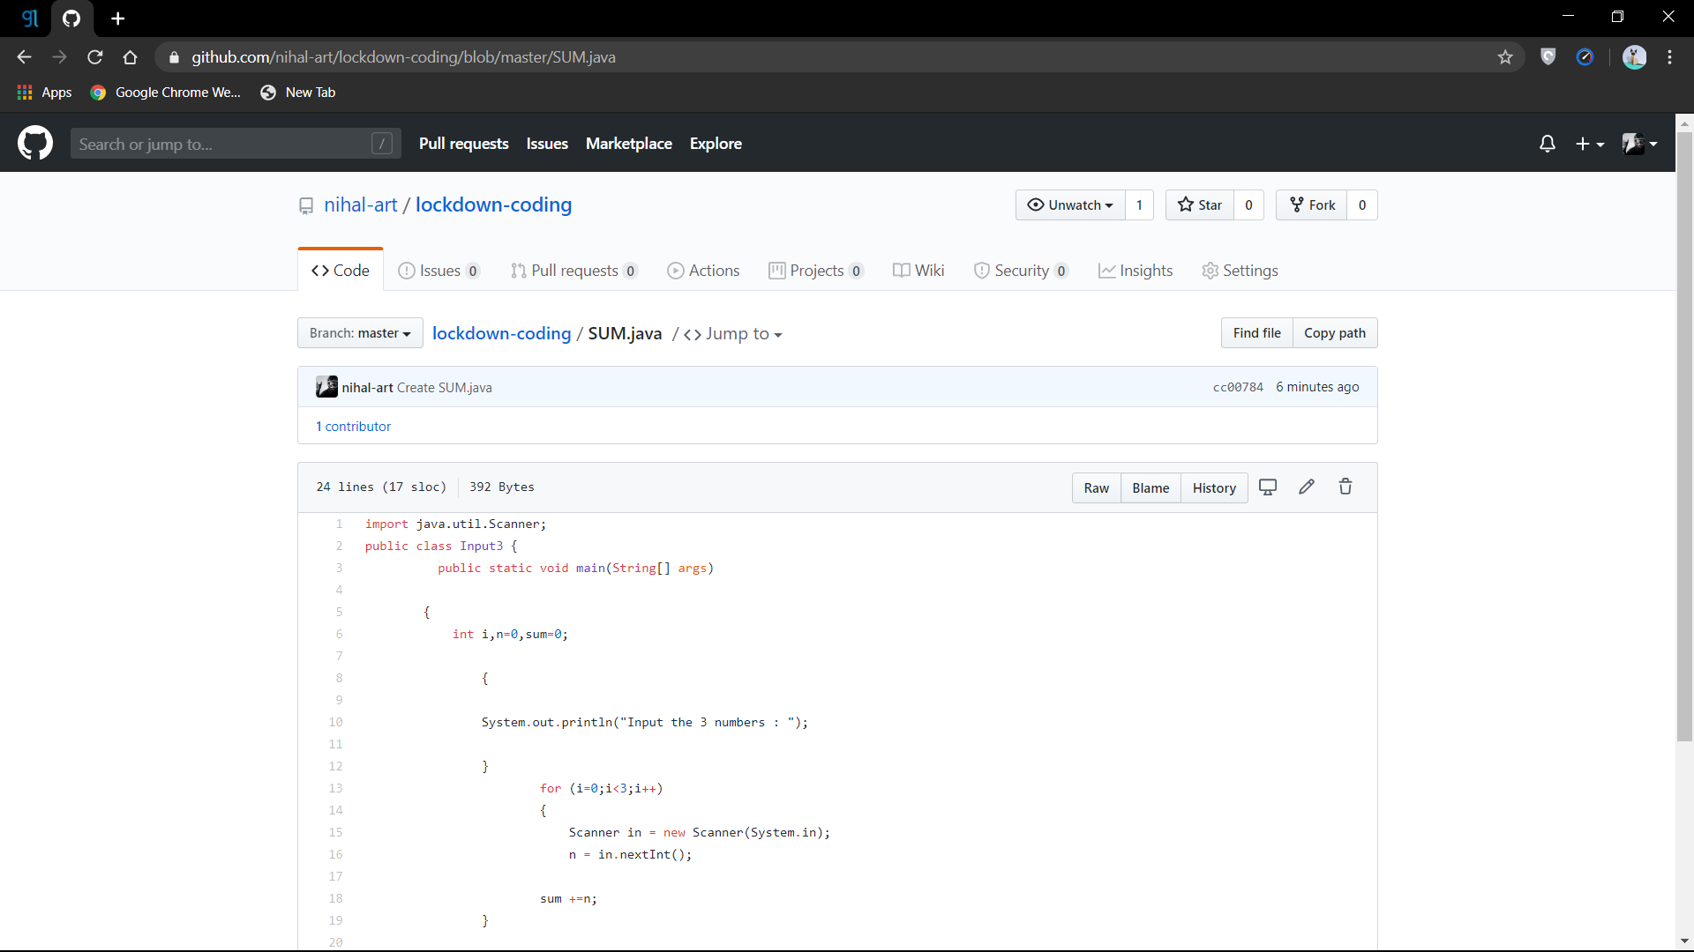

2. Write a C++ program to find the missing number in array

